**MACHAKOS UNIVERSITY**

**SCHOOL OF ENGINEERING AND TECHNOLOGY**

**DEPARTMENT OF COMPUTING AND INFORMATION TECHNOLOGY**

**SMART WASTE BIN**

**ELIZABETH WANGUI WARUGURU**

**J17-3006-2019**

**THIS PROJECT PROPOSAL IS SUBMITTED IN PARTIAL FULFILLMENT OF REQUIREMENTS FOR THE MACHAKOS UNIVERSITY AWARD OF BACHELOR OF SCIENCE IN COMPUTER SCIENCE.**

**April, 2023**

# **DECLARATION**

I hereby declare that this project documentation is my original work that represents my ideas and contributions. All the information and concepts presented in this project are accurate to my best of knowledge and its source are reliable and credible references.

Name: ……………………………………………………………………………….

Sign:………………………………………………….

Date: ………………………………….

Supervisor

Name: ………………………………………………………………………………….

Sign: ……………………………………………………

Date: …………………………………….

# **DEDICATION**

I dedicate this project to my family and friends (Mercymerine Atieno Omondi), whose unwavering support and encouragement have been the driving force behind my academic journey. Your constant motivation and belief in me have been instrumental through my academic journey.

# **ACKNOWLEDGMENT**

I thank God for His unwavering strength, guidance and blessings throughout my academic journey. I am deeply grateful for my family and friends who have supported me immensely and encouraged me throughout my studies.

# **ABSTRACT**

Waste management in rapidly growing cities, is confronted with numerous challenges arising from urbanization population density, inadequate infrastructure, and limited resources. As a result, there has been a significant rise in waste generation and environmental degradation. Although there are established collection points and contracted private companies for waste management, the coverage and frequency of waste collection can be inconsistent, leading to overflowing bins in public areas. Furthermore, inefficient waste collection practices and the lack of real-time monitoring contribute to the unsightly appearance of public spaces and pose health hazards. The accumulation of waste in overflowing bins attracts pests and vermin, creates unpleasant odors, and increases the risk of disease transmission. In addition, the inadequate infrastructure for waste management can lead to improper disposal and environmental pollution, further exacerbating the negative impact on ecosystems and human health.

In response to these challenges, this project proposal presents a Smart Waste Management System designed to optimize waste collection operations and promote sustainable waste management practices in rapidly growing cities. The proposed system utilizes smart bin technology equipped with ultrasonic sensors to accurately measure the fill levels in bins. When the predefined thresholds are reached, real-time notifications are sent to waste management companies addressing the shortcomings of traditional waste management approaches. This facilitates timely waste collection, minimizing overflowing bins and ensuring a cleaner environment. By optimizing resource allocation, reducing unnecessary pickups, and minimizing operational costs, the system aims to enhance overall efficiency in waste collection processes. The proposed Smart Waste Management System offers a solution to improve waste management practices and mitigate environmental impacts in rapidly growing cities.

Table of Contents

DECLARATION 2

DEDICATION 3

ACKNOWLEDGMENT 4

ABSTRACT 5

CHAPTER ONE: INTRODUCTION 8

1.1 Background of Study 8

1.2 Problem Statement 10

1.3 Objectives of Study 10

1.3.1 General Objectives 10

1.3.2 Specific Objectives 10

1.4 Justification of Study 11

1.5 Scope of Study 11

1.6 Limitations of Study 12

CHAPTER TWO: LITERATURE REVIEW 12

2.1 Introduction 12

2.2 Existing Systems 13

2.2.1 TakaTaka Solutions 13

2.2.2 Bins Group 13

2.2.3 Colnet Limited Kenya 13

2.2.4 Waste Afrika Kenya 14

2.2.5 Kamongo Waste Paper Kenya 14

2.3 Research Gaps 15

CHAPTER THREE: 15

RESEARCH METHODOLOGY 15

3.1 Introduction 15

3.2 Research Design 16

3.3 Population and Sampling Method 16

3.3.1 Population 16

3.3.2 Sampling Method 17

3.4 Methods of Data Collection 17

3.4.1 Surveys 17

3.4.2 Interviews 18

3.4.3 Observations 18

3.5 Data Analysis 18

3.5.1 Quantitative Analysis 18

3.5.2 Qualitative Analysis 19

3.5.3 Integration and Interpretation of Findings 19

3.6 Process Model 19

3.6.1 Agile Model 19

3.7 Project Schedule 22

3.8 Budget 22

CHAPTER FOUR 23

SYSTEM DESIGN AND ANALYSIS 23

4.0 Introduction 23

4.1 Data Analysis Results 23

4.1.1 Surveys 23

4.1.2 Interviews 23

4.1.3 Observations 24

4.2 Requirement Analysis 24

4.2.1 The Functional Requirements 24

4.2.2 The Non Functional Requirements 25

4.3 Propose Bin Architecture 26

4.4 Bin Sequence Diagram 27

4.5 Data flow Diagram 28

4.6 Physical Design 29

References 29

# **CHAPTER ONE: INTRODUCTION**

## **Background of Study**

The global economy is currently undergoing a significant transformation driven by globalization and rapid technological progress. This shift is characterized by technology, information, and knowledge emerging as fundamental pillars of this new era (Schwab, 2016). As a result, various aspects of modern life, such as education, professional activities, social interactions, and personal experiences, have been profoundly affected through the widespread adoption of Information and Communication Technology (ICT) (Kaware & Sain, 2015).

Investments in ICT are recognized as a key driver of productivity growth, which lays the foundation for improvements in the standard of living (Aker & Mbiti, 2010). Numerous studies conducted in developed countries at the firm, industry, and country level have shown a positive and economically significant relationship between ICT and productivity (Ardizzi et al., 2013). The productivity effect of ICT has been widely observed, supporting its role in enhancing economic performance.

As globalization and technological change continue to reshape the world, urbanization has become a prominent phenomenon. Urban populations are growing at a faster pace than cities can support, resulting in significant challenges. Cities struggle to provide basic urban services on an unprecedented scale, including housing, electricity, water supply, healthcare, education, and jobs (Harter, n.d.). The rapid growth of city populations has implications for climate change, as urbanization leads to increased consumption levels and the demand for resources, contributing to higher waste volumes (Satterthwaite, 2009).

The consequences of rapid urbanization and population growth present numerous challenges. Strains on infrastructure and resources result in inadequate housing, transportation, and healthcare, while the increased demand for goods and services leads to environmental degradation (Buhaug & Urdal, 2013). This includes elevated pollution levels, greenhouse gas emissions, and deforestation, ultimately impacting the ecosystem and human health. Furthermore, urban areas face significant obstacles in managing solid waste effectively. Improper disposal and management of municipal solid waste (MSW) cause various types of pollution, including air, soil, and water contamination. Inadequate waste management practices can result in health hazards, environmental pollution, and resource depletion (Alam & Ahmade, 2013).

The shift towards a technology-driven global economy has brought about significant changes through the adoption of ICT. ICT investments have been identified as drivers of productivity growth, enhancing economic performance. However, rapid urbanization and population growth pose considerable challenges, including strains on infrastructure, resources, and waste management. These challenges manifest in inadequate housing, transportation, healthcare, and environmental degradation. Effective waste management becomes crucial in mitigating the pollution and health risks associated with urban growth.

## **Problem Statement**

Waste management companies face significant challenges in optimizing their collection operations. The current approaches often rely on fixed schedules or manual monitoring, resulting in inefficient waste collection and resource misallocation. This leads to unnecessary pickups from bins that are not yet full, contributing to increased costs and environmental impact. Additionally, overflowing bins and inconsistent waste collection schedules affect the aesthetics and cleanliness of public spaces. Hence, an innovative solution is imperative to accurately detect waste levels in bins, promptly notify waste management companies, and facilitate efficient resource allocation for optimized waste collection.

The proposed solution is an innovative integrated waste management system that combines smart bin technology with real-time notifications. The smart bins are equipped with ultrasonic sensors, enabling precise measurement of the fill levels in the bins. Once a bin reaches a predefined threshold, such as 90% capacity, real-time notifications are immediately transmitted to the waste management company. These notifications can be conveniently received, promptly alerting the relevant personnel to schedule timely waste collection. By harnessing the power of this integrated waste management system, waste management companies can effectively optimize resource allocation, minimize unnecessary pickups, reduce operational costs, and achieve enhanced overall efficiency in waste collection processes. Moreover, the solution significantly contributes to environmental sustainability by promoting efficient waste management practices.

## **Objectives of Study**

### **1.3.1 General Objectives**

The main objective is to develop an smart waste management system.

### **1.3.2 Specific Objectives**

1. To review and analyze the current waste management systems in place.
2. To design a smart waste management system based on the findings of the review.
3. To develop an smart waste management system for efficient waste collection.
4. To test and validate the new smart waste management system for its performance.

## **Justification of Study**

The current problem of inefficient waste collection practices, resource misallocation, and compromised aesthetics poses a significant threat to the environment and overall sustainability. The reliance on fixed schedules and manual monitoring leads to overflowing bins, increased costs, and detrimental environmental consequences such as air pollution, soil contamination, and ecosystem degradation. These issues not only affect the immediate surroundings but also contribute to the global challenge of waste management and climate change. By developing an smart waste management system that leverages smart bin technology, sensors, and real-time notifications, the project aims to address these environmental challenges. By optimizing waste collection operations, minimizing unnecessary pickups, and reducing operational costs, the proposed solution seeks to mitigate the negative environmental impact while promoting a cleaner and more sustainable environment. Additionally, the project aligns with Sustainable Development Goal (SDG) number 11: Sustainable Cities and Communities, by striving to create inclusive, safe, resilient, and sustainable cities through advanced waste management practices.

## **Scope of Study**

This study aims to explore the development and implementation of an smart waste management system with a specific focus on smart bin technology and real-time notifications. It will delve into the design and deployment of smart bins equipped with sensors for accurate waste level measurement. The study will investigate the integration of these smart bins into a comprehensive waste management system that includes real-time notifications to alert waste management companies when bins reach predefined thresholds. Additionally, the study will encompass the development of a management module that provides a user-friendly interface for tracking bin statuses and generating insightful reports. It will entail a detailed analysis of the technology used, the implementation process, and the functionalities of the integrated system.

## **1.6 Limitations of Study**

1. Connectivity and Network Reliability: Uninterrupted connectivity and reliable network infrastructure are essential for real-time data transmission and notifications, and challenges in this area could affect the system's performance.
2. Power Supply and Energy Efficiency: Ensuring continuous power availability and optimizing energy efficiency for the smart bins and communication devices is important, especially in locations with unreliable power sources.

# **CHAPTER TWO: LITERATURE REVIEW**

## **2.1 Introduction**

This chapter presents a comprehensive overview of the existing literature on Waste Collecting Management System principles, theories, and their operational mechanisms in achieving their intended goals. The focus of this literature review is centered on the management of waste collection using the Waste Collecting Management System, aiming to establish a solid theoretical foundation for the development of waste collection systems in the specific region. By drawing insights from previous studies, this chapter seeks to identify key considerations and best practices for the design and implementation of efficient waste collecting systems, ultimately informing the construction of an effective and sustainable waste management infrastructure.

## **2.2 Existing Systems**

### **2.2.1 TakaTaka Solutions**

TakaTaka solutions is a waste management company in Kenya that has implemented a comprehensive and integrated waste management system which includes waste collection, sorting, recycling and composting. They offer waste management services to all types of waste producers residential houses and apartments, office building, restaurants, schools, shopping malls, factories and hospitals. They provide their customers bins and bin liners in different colors to make it easier to source separate the waste. They then schedule waste collection methods such as door-to-door collection and collection points, they ensure the proper segregation and handling of different waste streams.

### **2.2.2 Bins Group**

Bins (Nairobi) Services Limited, incorporated in 1986, is a leading garbage collection, disposal, and recycling company in Nairobi. With over three decades of experience, the company has established itself as a reliable and reputable service provider in the industry. Their services include collection of household garbage, green Waste and bulky Items, collection, disposal and recycling of commercial, industrial and construction waste. Known for their reliability, the company ensures scheduled pickups and prompt responses to customer requests, offering high-quality and professional garbage collection services.

### **2.2.3 Colnet Limited Kenya**

Colnet Limited offers a comprehensive range of waste management services, ensuring that their clients have access to suitable containers that match their waste production requirements. Their commitment to prompt collection services ensures that waste is efficiently removed from the client's premises. A key focus of the company is to handle waste legally, environmentally, and with minimal disruption to their clients' businesses. By utilizing the latest disposal technologies, Colnet Limited ensures that their services are efficient and responsible. They provide customized waste pickup programs for various needs, including curbside pickup for residential areas, commercial and industrial collections, yard waste pickup, bulk waste pickup, food and organic waste pickup, and scheduled waste pickup. The availability of dumpsters further enhances their waste disposal capabilities.

### **2.2.4 Waste Afrika Kenya**

Waste Afrika Kenya Solid Waste Advisory Services is a specialized company in Kenya that offers a range of solid waste management services and consultancy. Their expertise lies in the safe removal and disposal of asbestos-containing materials, demonstrating a strong commitment to handling hazardous waste responsibly and ensuring environmental and human safety. In addition, the company provides integrated solid waste management services and consultancy, encompassing source reduction, source separation, recycling, and materials recovery. By promoting sustainable practices, Waste Afrika Kenya contributes to the efficient use of resources and minimizes waste generation. Their emphasis on safe storage and handling of hazardous materials reflects their dedication to preventing environmental pollution and protecting public health. Overall, Waste Afrika Kenya Solid Waste Advisory Services appears to be a reliable and environmentally conscious company, providing comprehensive solutions for solid waste management in Kenya.

### **2.2.5 Kamongo Waste Paper Kenya**

Kamongo Waste Paper Kenya is a reliable and customer-oriented company that specializes in waste paper collection and recycling services in Kenya. They have a proven track record of collecting large quantities of waste paper on a daily basis throughout the country. Their waste paper collection services provide a convenient and responsible solution for businesses and individuals seeking proper disposal options. Additionally, Kamongo Waste Paper Kenya offers goods and parcels transportation services, ensuring reliable and guaranteed delivery of goods across Kenya. Their emphasis on recycling, particularly focusing on old newspapers, demonstrates their commitment to promoting sustainable practices and contributing to the circular economy. Moreover, their paper shredding service enables businesses to securely dispose of sensitive documents while maintaining confidentiality. Kamongo Waste Paper Kenya is a reputable company that provides comprehensive waste management solutions, promoting environmental conservation and resource optimization.

## **2.3 Research Gaps**

The existing waste management systems reviewed, including TakaTaka Solutions, Bins Group, Colnet Limited Kenya, Waste Afrika Kenya, and Kamongo Waste Paper Kenya, demonstrate certain gaps that can be addressed by a smart bin project. These gaps include the lack of integration of smart technology in waste management operations, limited waste segregation options, inadequate tracking and monitoring capabilities, insufficient focus on recycling and the circular economy, limited hazardous waste management measures, and the absence of integration with transportation services. By incorporating smart bins with advanced features, such as real-time monitoring, and data analytics, a smart bin project could provide a comprehensive waste management solution that optimizes waste segregation, enhances recycling efforts, improves operational efficiency, and delivers personalized services to customers while integrating with transportation services for more efficient waste transportation.

# **CHAPTER THREE:**

# **RESEARCH METHODOLOGY**

## **3.1 Introduction**

The aim of this chapter is to introduce the research methodology that will be utilized in the development of the Smart Waste Management System. Research methodology encompasses the systematic approaches and techniques employed to gather, select, process, and analyze relevant information in a research project. In this chapter, an overview of the research methods to be employed will be provided, outlining the steps to be taken in gathering and analyzing data for the implementation of the Smart Waste Management System.

### **3.2 Research Design**

The research design involves a mixed-methods approach that combines quantitative and qualitative methods. Surveys will be utilized to gather quantitative data on waste management practices and perceptions, while in-depth interviews will provide qualitative insights into system requirements and expectations. Direct observations at waste collection points and sensor data collection will provide real-time data on bin usage and performance. User feedback and field testing will contribute to assessing usability and effectiveness. Through an iterative process aligned with Agile principles, the research design allows for continuous improvement based on data analysis, user input, and field testing, ensuring the integrated waste management system meets stakeholder needs and enhances waste collection efficiency and sustainability.

## **3.3 Population and Sampling Method**

### **3.3.1 Population**

The target population consists of waste collection companies and waste collection points. Waste collection companies are key stakeholders responsible for waste management operations, providing insights into current practices and requirements. Waste collection points represent various locations where smart bins will be implemented, allowing for data collection on bin usage patterns and collection efficiency. Engaging with them enables a comprehensive understanding of waste management practices and facilitates the development of an optimized smart bin system.

### **3.3.2 Sampling Method**

For this smart bin project, I will employ purposive sampling as the sampling method. Purposive sampling involves purposefully selecting waste collection companies and specific waste collection points that are representative of different locations, waste volumes, and waste management practices. This method will enable the research team to gather targeted and in-depth information from key stakeholders directly involved in waste management operations. By purposefully selecting participants with expertise and firsthand knowledge in waste collection, the research project can gain valuable insights into the current practices, challenges, and expectations related to the integrated waste management system. The purposive sampling approach ensures that participants have relevant expertise and insights specific to the smart bin project, allowing for a focused exploration of their perspectives. This method will facilitate a deeper understanding of the specific waste management context and provide valuable information to inform the development and optimization of the smart bin system for improved waste collection practices.

## **3.4 Methods of Data Collection**

Data collection for the smart bin project will involve surveys, interviews, and observations. These methods enable a comprehensive understanding of waste management practices and the effectiveness of the smart bin system.

### **3.4.1 Surveys**

Surveys will be designed and distributed in electronic or in print form to waste management companies, municipal authorities, residents, or other relevant stakeholders. The respondents will be given a designated time-frame to complete the surveys, and the collected data will be compiled for analysis. Surveys will gather quantitative data on waste management practices, perceptions, and feedback.

### **3.4.2 Interviews**

It entails conducting in-depth interviews with key stakeholders, such as waste management company representatives, municipal officials, or residents. These interviews will be conducted face to-face or over the phone depending on the availability and preferences of the participants. The interviews will follow a structured or format to ensure consistency in data collection, and they will be documented through notes for later analysis. Interviews will allow for gathering qualitative data and obtaining detailed insights into their experiences, opinions, and suggestions.

### **3.4.3 Observations**

This is about making direct observations at waste collection points or designated areas to collect observational data on bin usage patterns, waste generation rates, or collection efficiency. It will involve physically visiting waste collection points or designated areas to directly observe and record information on bin usage patterns, waste generation rates, and collection efficiency. Then document the observations, including timestamps, descriptions, and any relevant details, to capture the real time practices and behaviors accurately.

## **3.5 Data Analysis**

The collected data from surveys, interviews, and observations will be analyzed using both qualitative and quantitative analysis methods to derive meaningful insights and address the research objectives of the smart bin project.

### **3.5.1 Quantitative Analysis**

Quantitative data obtained from surveys will be analyzed using statistical techniques. This analysis will involve calculating descriptive statistics, such as frequencies, percentages, and measures of central tendency, to summarize and describe the survey responses. Inferential statistics may also be applied to examine relationships between variables or test hypotheses, allowing for deeper insights into waste management practices and perceptions.

### **3.5.2 Qualitative Analysis**

Qualitative data obtained from interviews and observations will be analyzed using thematic analysis. This analysis approach involves identifying recurring themes, patterns, and concepts within the interview transcripts and observational notes. The data will be carefully reviewed, coded, and organized into meaningful themes and sub-themes, allowing for a rich understanding of stakeholders' experiences, opinions, and suggestions related to the smart bin project.

### **3.5.3 Integration and Interpretation of Findings**

The findings from the quantitative and qualitative analyses will be integrated and interpreted to provide a comprehensive understanding of the smart bin project. The results will be synthesized, allowing for the identification of key themes, trends, and insights across the data sources. The integrated findings will be discussed in the context of the research objectives and the practical implications for optimizing waste management process Integration and enhancing the effectiveness of the smart bin system.

## **3.6 Process Model**

The process model for this Project outlines a structured framework that guides the development and implementation of the smart waste management system. It ensures an organized and efficient approach, enabling effective resource management and progress tracking throughout the project life cycle. Agile will be the process model for the project.

### **3.6.1 Agile Model**

I am choosing the Agile model for the smart bin project because it allows for adaptability in a rapidly evolving technological landscape. With the Agile methodology, I can respond quickly to changes, incorporate feedback from stakeholders and end-users, and make incremental improvements throughout the development process. By breaking the project into shorter iterations called sprints, I can deliver functional increments of the smart bin system, gather user feedback, and mitigate risks more effectively.

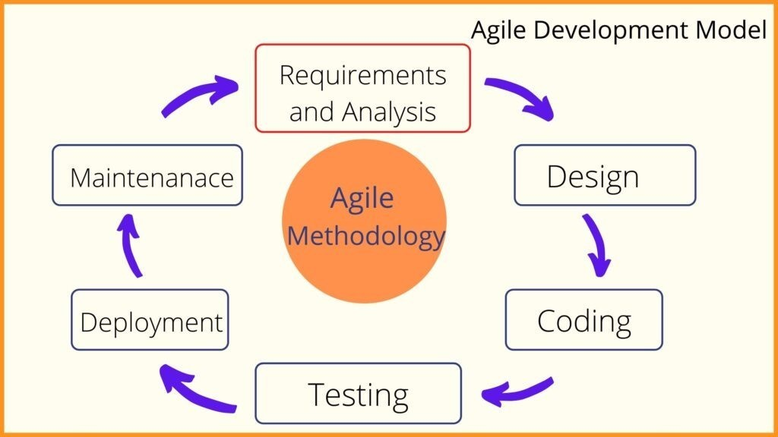

*Figure 3.1 Process Model*

#### **3.6.1.1 Requirement Analysis**

It involves identifying and understanding the specific needs and expectations. It includes conducting thorough research on waste management practices, conducting surveys and interviews to gather user requirements, and analyzing existing systems and technologies. The gathered information will be used to define the functional and non-functional requirements of the smart bin system, ensuring it addresses the key challenges and provides the desired features and functionalities.

#### **3.6.1.2 System Design**

This involves designing the overall structure of the smart bin system, including the hardware components, software modules, and data management mechanisms. This phase also involves defining the user interface, communication protocols, and data flow between the smart bins and the central management system. The design will be based on the identified requirements and will aim to optimize waste collection, monitoring, and management processes.

#### **3.6.1.3 Development and implementation**

The development and implementation phase involves translating the system design into a functional smart bin system. This includes coding and programming the software, integrating hardware components such as sensors and configuring the necessary infrastructure. The implementation process will also include testing to ensure the system functions correctly and meets the defined requirements.

#### **3.6.1.4 Quality assurance**

Quality assurance ensures that the system meets the desired quality standards. This involves conducting comprehensive testing, including functional testing and performance testing to validate the system's performance and reliability. Any identified issues or bugs will be addressed and resolved to ensure the system operates smoothly and provides accurate waste management outcomes.

#### **3.6.1.5 Deployment and Maintenance**

This involves installing the smart bins, configuring the communication infrastructure, and connecting them to the central management system. Once the system is set up, I will perform testing and evaluation to assess its functionality, performance, and effectiveness. This will involve simulating waste generation, monitoring the fill levels, and analyzing the data collected. There will also be maintenance procedures that will be established for regular monitoring and maintenance activities to ensure the system operates efficiently, any issues are addressed promptly, and necessary updates or enhancements are implemented to improve system performance and functionality.

## **3.7 Project Schedule**

| Project Activity | Duration in weeks |
| --- | --- |
| Requirement Analysis | 1 |
| System Design | 2 |
| Development | 6 |
| Testing | 1 |
| Deployment | 1 |
| Maintenance | 1 |
| Total | 12 Weeks |

*Table 3.1 project schedule*

## **3.8 Budget**

|  |  |
| --- | --- |
| **Items** | **Price** |
| 1. Bin | Ksh 350 |
| 1. Ultrasonic Sensors | Ksh 500 |
| 1. Arduino micro controller | Ksh1000 |
| 1. Cables and connectors | Ksh 700 |
| 1. Battery | Ksh 1000 |
| 1. Survey | Ksh 1000 |
| Total | Ksh 4550 |

*Table 3.2 Budget*

# CHAPTER FOUR

# SYSTEM DESIGN AND ANALYSIS

## 4.0 Introduction

## 4.1 Data Analysis Results

During the data analysis phase for the Smart Waste Management System project all of the data collected via surveys, interviews, and direct observations was carefully examined. The surveys yielded quantifiable data that offered insightful information about stakeholder opinions and the state of waste management techniques today. Statistical methods such as percentages and frequency distributions were used to analyze the replies. One noteworthy conclusion is that respondents generally agreed about the difficulties encountered in garbage collection; a sizable portion of them brought up problems with ineffective pickup schedules and overflowing bins in public spaces

### 4.1.1 Surveys

The results of the survey during the data analysis is the quantitative insight into the existing waste management practices and the perception of the stakeholders. The population sample included waste management professionals, municipal authorities and residents, who provided the understanding on the prevailing challenges within the waste collection system. Most of the issues that were identified include inefficient pickup schedules and overflowing bins in public spaces. This resulted to the need of a more dynamic and responsive approach in waste management.

### 4.1.2 Interviews

Through interviews with key stakeholders, led to qualitative aspect to the data analysis. A usual idea that came up from the interviews recommended a collective interest in the integration of real-time monitoring systems. The stakeholders expressed the necessity for technology driven solutions to address challenges promptly. The interviews provided a detailed and insightful look at the challenges in waste management and also the views of the people in the field.

### 4.1.3 Observations

This involved direct observation at waste collection points which offered real-time information about how they are filled, how they are emptied and where there are challenges in operations of the current waste management system. The information from the observation showed that there is a need for a new waste management system that is capable of adjusting to needs of people who produce waste and optimize resource allocation based on real time demand.

## 4.2 Requirement Analysis

The requirement analysis phase is important as it helps to establish the functionalities of the smart waste bin and also define its characteristics. It outlines the key aspects of the project’s functional and non-functional requirements, which are derived from the analysis of data, surveys, interviews and observations. It serves as a basic document with the goal of establishing agreement among it users and the developers and an all inclusive guide for the design and development of the project in order to meet its intended objectives.

### 4.2.1 The Functional Requirements

The functional requirements outline the specific actions and capabilities that the smart waste bin must deliver. It ensures the bin’s ability to effectively manage waste by including tasks such as waste collection and resource allocation. The data gathered from the data analysis result provided an understanding into the waste generation patterns, collection schedules and the needs of the users. The following are the system's requirement for the project:

1. Real time waste level Monitoring

There will be continuous monitoring and providing real-time updates on waste levels in waste bins.

1. Data Publishing to Adafruit IO.

For the remote access and analysis, waste level data will be published to the Adafruit IO

1. Alert Mechanism

When waste levels reach critical thresholds, there will be trigger alerts.

### 4.2.2 The Non Functional Requirements

The non-functional requirements focus on the performance characteristics of the bin by ensuring its reliability, scalability and maintainability. Observations and analysis of data helped in assessing the bin’s ability to handle varying waste volumes and adapt to advancement in technology. The following are the non-functional requirements for the project:

1. Performance

Minimal latency in waste level updates should be assured.

1. Maintenance and usability

It should be easy to maintain and navigate through its functionality.

1. Availability

It should always be available, with minimum downtime for maintenance and upgrades.

## **4.3 Propose Bin Architecture**

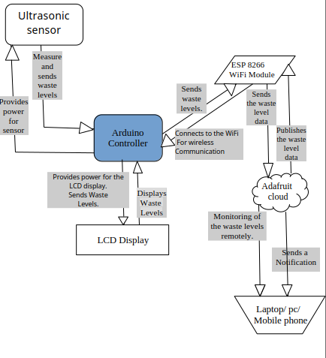

*Figure 4.1 Proposed Bin Architecture*

## **4.4 Bin Sequence Diagram**

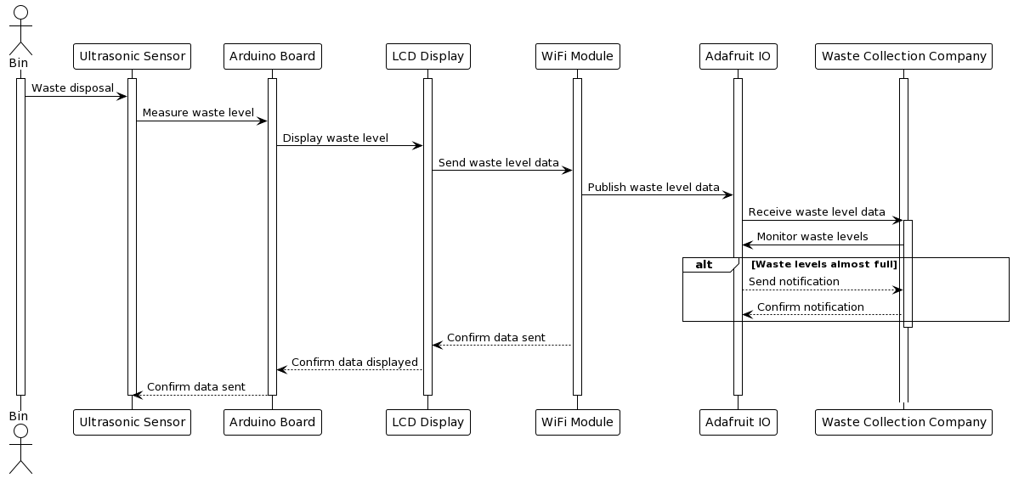

*Figure 4.2 Bin Sequence Diagram*

## **4.5 Data flow Diagram**

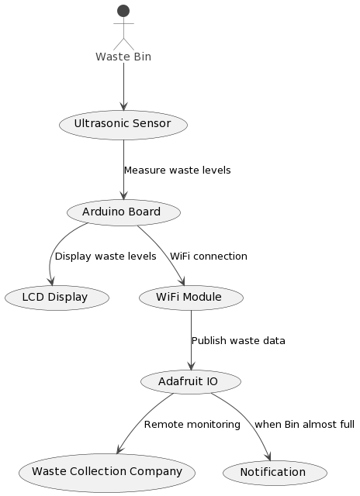

*Figure 4.3: Bin data-flow diagram*

## **4.6 Physical Design**

## **References**

Aker, J. C., & Mbiti, I. M. (2010). Mobile Phones and Economic Development in Africa. *Journal of Economic Perspectives*, *24*(3), 207–232. <https://doi.org/10.1257/jep.24.3.207>

Alam, P., & Ahmade, K. (2013). *IMPACT OF SOLID WASTE ON HEALTH AND THE ENVIRONMENT*. *2*(2315).

Ardizzi, G., Petraglia, C., Piacenza, M., & Turati, G. (2013). Measuring the Underground Economy with the Currency Demand Approach: A Reinterpretation of the Methodology, With an Application to Italy. *Review of Income and Wealth*, n/a-n/a. <https://doi.org/10.1111/roiw.12019>

Buhaug, H., & Urdal, H. (2013). An urbanization bomb? Population growth and social disorder in cities. *Global Environmental Change*, *23*(1), 1–10. <https://doi.org/10.1016/j.gloenvcha.2012.10.016>

Harter, G. (n.d.). *Senior Associate +91-99-3026-2107 sandeep.dave@booz.com*.

Kaware, S. S., & Sain, D. S. K. (n.d.). *ICT Application in Education: An Overview*. *02*.

*We collect waste from households, businesses and factories. We take the waste to our sorting sites where we sort it into more than 40 fractions.* (n.d.). TakaTaka Solutions. Retrieved June 22, 2023, from <https://takatakasolutions.com/>

*Bins Nairobi Ltd – Bins Nairobi Ltd*. (n.d.). Retrieved June 24, 2023, from <https://binsgroup.com/>

*Colnet Limited Kenya*. (n.d.). Retrieved June 23, 2023, from [https://www.colnet.co.ke](https://www.colnet.co.ke/)

*Waste Afrika Kenya*. (n.d.). Retrieved June 24, 2023, from <https://wasteafrikakenya.co.ke/>

*Home*. (n.d.). Kamongo Waste Paper Kenya. Retrieved June 24, 2023, from <https://quantumplus.co.ke/kamongo/>